Core transversal competencies

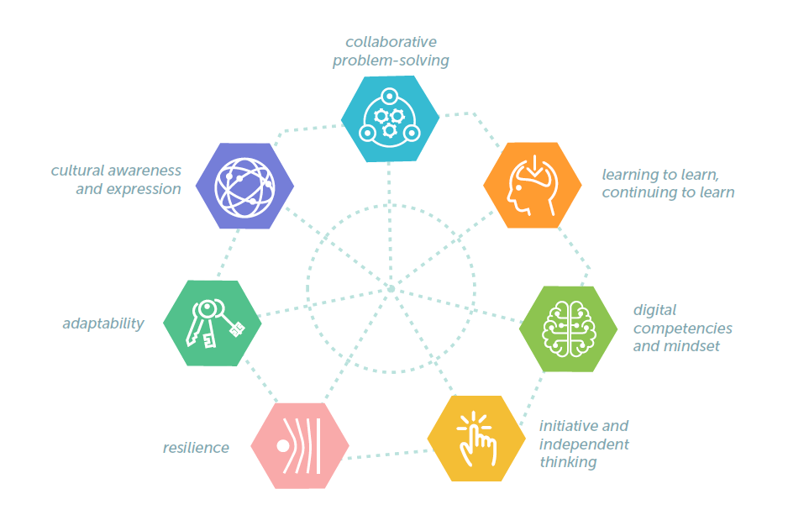
Figure 1: Seven core transversal skills
Transversal competencies, are:
- Transferable across domains geographies, work, and life contexts.
- Relate to social and interpersonal relations.
- Are cross-functional and cross-curricular.
- If not communicated explicitly, they can remain undervalued or unrecognised.
- Essential tools in significant and accelerated change.
- Can be observed, evidenced, and developed.
- Are learnt through experience and development.
- In their development, they have a symbiotic relationship with improved self-awareness and self-knowledge.
Transversal skill | Definition and comments | Exemplars
1. Collaborative problem solving | “Collaborative problem-solving competency is the capacity of an individual to effectively engage in a process whereby two or more agents attempt to solve a problem by sharing the understanding and effort required to come to a solution and pooling their knowledge, skills and efforts to reach that solution.” – OECD  The reader should note that collaborative problem-solving involves exercising other key competencies, notably creativity, resilience, initiative, cultural awareness.  Effective collaboration requires additional qualities including, empathy, adaptability, initiative, independent thinking and working across cultural and organisational boundaries. | Exemplars  - Problem based learning  - Enquiry based learning  - Team work, group projects  - Industry informed/led interdisciplinary Hackathons
2. Learning to learn | Creating independent learners with the skills and knowledge required to learn effectively and continue to learn has emerged as one of the mostly highly valued transversal skills globally. | Exemplars:  - Creating active learning environment where students have to contextualise and apply knowledge (flipped classroom).  - Facilitating group learning and sharing of knowledge by creating a class MS Teams group.  - Enquiry based learning  - Cornell notes - Effective note taking  - Research and study skills
3. Digital competencies and mindset | Digital competencies are a critical enabler for organisations to operate efficiently and effectively. Key driver for growth and innovation. Organisations need to have embedded a digital strategy in their overall business strategy, instead of merely deploying digital and ICT tools as an add-on. | Exemplars:  - Development of core ICT skills, information and digital literacy underpinned by good digital citizenship.  - Use of modern, industry standard tools, technologies, and platforms to solve complex problems and create digital content.  - Effective use of tools to enhance and support communication and collaboration.  - Critical analysis and evaluation of technology platforms/tools.  - Encouraging students to acquire additional technical competencies through experimentation and exploration.
4. Initiative and independent thinking | The ubiquity of access to information had paradoxically resulted in a much higher level of ambiguity. Students must demonstrate initiative, proactivity and independent thinking. Workers in the digital age need to be able to act effectively and swiftly in complex situations. | Exemplars:  - Active and problem based learning activities provide students with opportunities to develop independent thinking and initiative.  - Requiring students to define, prioritise and complete tasks without direct oversight.  - Inter-disciplinary or subject hackathons  - Research informed teaching and learning activities  - Rewarding students for going beyond basic mastery of skills and the curriculum to explore and expand their own learning and opportunities to gain expertise.
5. Resilience | Resilience in workers means the ability to stay positive, adaptable and effective, when suffering setbacks such as failed innovations, backfiring interventions, criticism or demanding clients.  The key to exercising effective resilience is treating problems as challenges that one learns from through engaging with, combatting and overcoming.  Opportunities to fail fast and often. Preforming root cause analysis and writing up post-mortems | Exemplars:  - Problem based learning  - Supporting communication and collaboration amongst students to foster social support networks.  - Opportunities for reflective learning  - Chaos monkey  - Assignments and mini projects that are delivered in increments with reflection and analysis between stages.  - CAs with evolving requirements between deliverables.
6. Adaptability | When combined with resilience, good adaptability skills enable students to see problems as challenges and opportunities, to stay positive when faced with difficulty. | Exemplars:  - Requiring students to adapt to varying roles and responsibilities in group assignments.  - Problem and projects-based learning with ambiguous and changing requirements/priorities.
7. Cultural awareness and expression | We live in a highly interconnected global economy and frequently come into contact with people from other cultures. The ability to work across cultural boundaries and adapt to different cultural norms with agility, respect and efficiency is therefore paramount. | Exemplars:  - Peer reviews – give students the opportunity to give and take constructive criticism of others work. IE – code reviews or PRs using GitHub.  - Requiring students to consider the ethical and cultural issues related to the development and use of technology.

Transversal competencies - programme mapping template

 | Collaborative problem solving | Digital competencies and mindset | Initiative and independent thinking | Resilience | Adaptability | Cultural awareness and expression
Semester 1
Semester 2
Semester 3
Semester 4
Semester 5
Semester 6
Semester 7
Semester 8

